Switchboards, Load Centers, and Power Panel Capacity Sizing
Norbert Doerry
May 2, 2026
- Introduction
The rating of switchboards (Figure 1), load centers (Figure 2), and power panels (Figure 3) determines the size and current carrying capability of the busbars internal to the distribution equipment. Load centers and power panels typically only have one source of power at a time; the electric power load analysis (EPLA) is used to determine the maximum load to expect; this load can be converted to current. Most distribution system equipment busbars come in incremental sizes, each with a maximum current rating. The smallest standard sized busbar that has a maximum current rating to carry the maximum expected operating load (including margin and service life allowance) is usually chosen. If a large load is expected to connect to the load center or power panel while the ship is in service, this load may be added to the total operating load in addition to the service life allowance.
Calculating the power rating of switchboards is usually more complicated. Switchboards frequently contain bus-tie circuit breakers; current may flow through the switchboard from one bus-tie to another bus-tie and not serve any of the loads attached to the switchboard. The busbars should be capable of supporting the maximum current to loads as well as through the bus-tie circuit breakers. The size of the busbars is also influenced by the presence of non-fundamental frequency currents and common mode currents.
The physical size and weight of switchboards, load centers, and power panels are also dependent on the voltage, the number and type of circuit breakers, disconnects, fuses, and control elements. Specifications, datasheets and other information from the manufacturer should be consulted to estimate the physical size and weight. See MIL-STD-23928 and its associated specification sheets for power panel examples. In early-stage design, it may be possible to scale switchboard and load center data from an existing ship.

Figure 1: U.S.S. Goldsborough (DDG 20) Ship Service Switchboard (Image is in the public domain)

Figure 2: U.S.S. Cole (DDG 67) Load Center (U.S. Navy Photo)
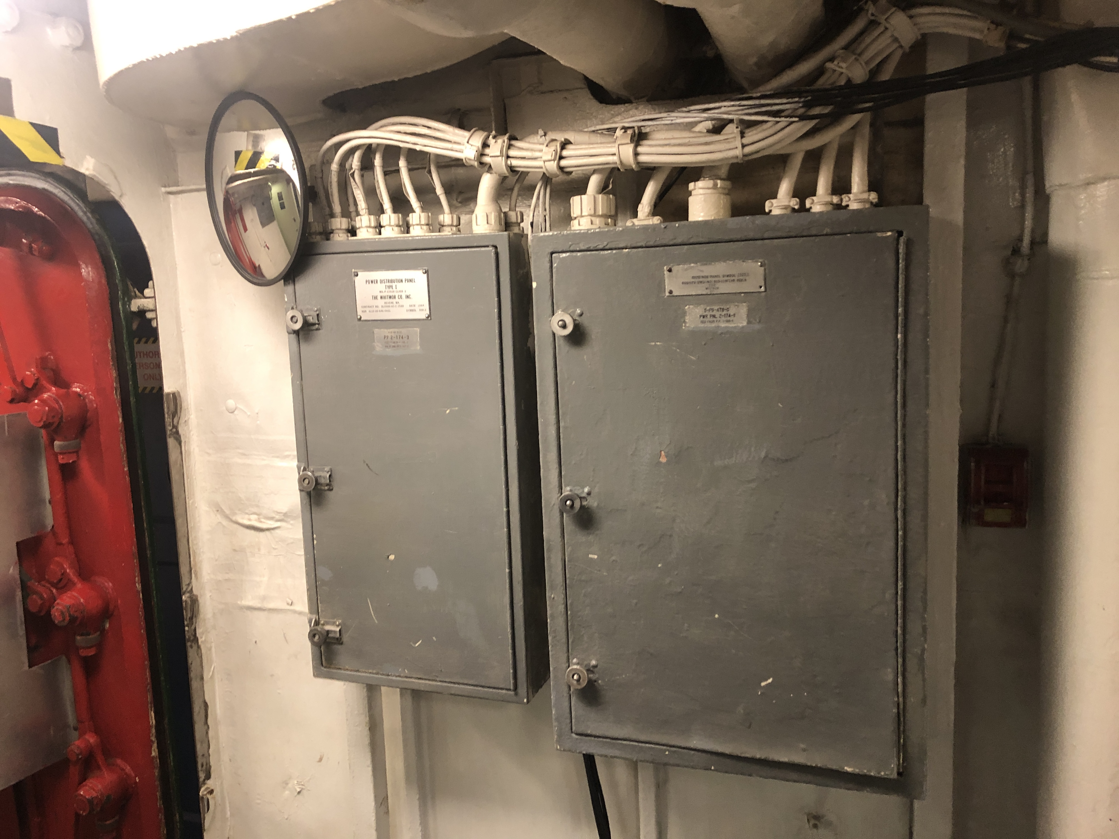
Figure 3: U.S.S. Midway (CV 41) Power Panel (Photo by Norbert Doerry)
- Considerations
  - Load analysis
    - Load factor analysis
Load factor analysis is detailed in DPC 310-1 and IEEE Std. 45.1. When applied to determining the operating load for switchboards, load centers, and power panels, the load factors may be different than those used at the total ship level. Specifically, the ship may incorporate multiple installations of a piece of equipment, yet at a ship wide level, only operate a fraction of them for a given operational condition. For determining the operating load for a switchboard, load center or power panel, the maximum number of the equipment in an operating condition that could be powered by the distribution equipment should be assumed to be on and have an appropriate load factor.
Load factor analysis is appropriate if most of the operating load is due to constant power loads where overloading by cycling loads is not anticipated.
For switchboards, load centers, and power panels with energy storage that is only intended to power the loads directly connected to the switchboard / load center / power panel, the energy storage should be considered a load with the appropriate level of charging power. If the energy storage is intended to power other loads as well, the system should be analyzed both with the energy storage acting as a source, and as a load.
    - Zonal load factor analysis
Zonal load factor analysis is detailed in DPC 310-1 and is recommended for calculating the maximum operating load for switchboards, load centers, and power panels if a significant amount of the load is due to cycling loads. Zonal load factors account for the variability in the total operating load due to having non-constant power loads. The zonal load factor method requires for each load: the load factor for the 24-hour average calculations; the connected load; and the peak load. The zonal load factor method will generally result in a larger operating load as compared to the traditional load factor method.
    - Demand factor analysis
Demand factor analysis is a legacy technique for determining the rating of the feeder cable supplying a load center; it can also be used in early-stage design to estimate the required busbar size within the load center. In early-stage design, demand factor analysis may be useful in estimating the bus bar size for power panels (if the power panel sizes are even estimated in this stage of design). For later stages of design, the zonal load factor method or the stochastic load analysis method detailed in DPC 310-1 are preferred methods.
In demand factor analysis, a demand factor is obtained based on the total connected load. Figure 4 is employed for 450 volt three-phase ac load centers (connected load expressed in amps); Figure 5 is employed for all other load centers (connected load expressed in kW). The demand factor is multiplied by the connected load to estimate the required rating of the load center bus bars.
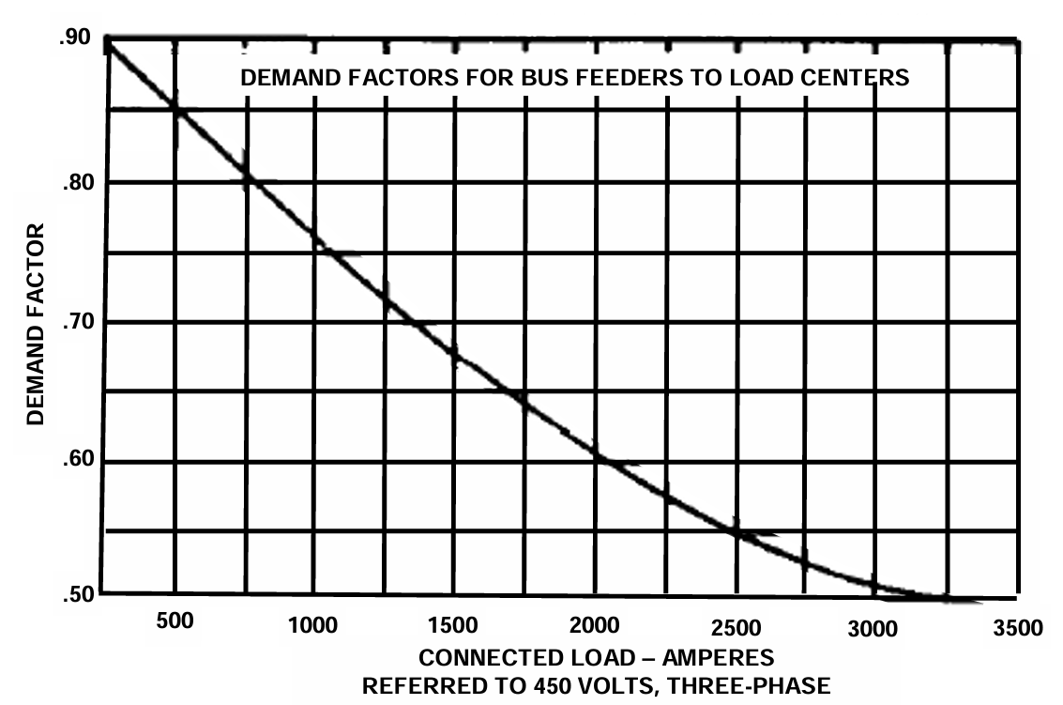
Figure 4: Demand Factor for 450 volt, three-phase load centers (DPC 310-1)
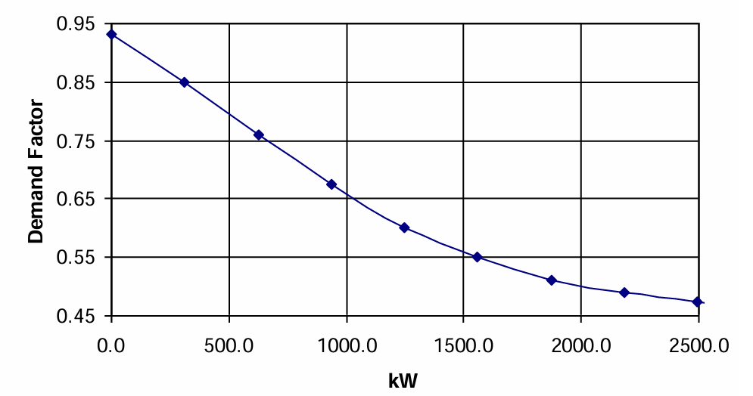
Figure 5: Demand Factor for load centers other than 450 volt, three phase load centers (DPC 310-1)
    - Load flow analysis
Determining the maximum operating current for a switchboard with bus-tie breakers is not trivial. It is not sufficient to just calculate the total operating current for the loads directly connected to the switchboard or via directly connected load centers. The impact of loads and sources connected via the bus-ties should also be considered. The different options for configuring both generation and load systems should be accounted for. To find the maximum operating current for the switchboard, many cases must typically be analyzed. Doerry (2025) provides additional guidance for performing a load flow analysis.
    - Limiting load flow analysis
In early-stage design, it may be preferable not to perform a full load flow analysis, but instead perform a limiting load flow analysis. As described by Doerry (2025), the limiting load flow method determines an upper bound for the maximum operating current. It compares the maximum load connected to the switchboard to the maximum generation connected to the switchboard and uses the smaller number. For energy storage and bus-ties, the cases where they are a source are considered in addition to the cases where they are a load. While multiple calculations are likely to be performed under the limiting load flow analysis, the number of calculations is likely to be much less than for the load flow analysis method.
  - Margin and Service Life Allowance
Margins account for uncertainty in the operating load estimate during the design and construction of a ship; service life allowance accounts for growth in load while the ship is in-service. Margins and service life allowance are applied to the maximum calculated operating load to determine the maximum operating load the distribution equipment should be capable of handling. The maximum operating load is typically converted to a current value. IEEE Std. 45.1 recommends the following margins and SLA:
Detail Design Margin: 5% for existing follow-on designs to 20% for new first-time designs
Construction Margin: 5% for existing follow-on designs to 20% for new first-time designs
SLA: 20% (1% per year for 20 years)
When the ship is initially constructed, switchboards, load centers, and power panels should include provisions for incorporating additional loads or circuits while the ship is in-service. This can be accomplished by providing a physical spare circuit breaker, by allocating a slot into which a physical circuit breaker may be placed in (Figure 6 is an example of a home power panel with three spare circuit breaker slots), or as simple as a space and weight reservations to install an additional frame for circuit breakers.
Provisioning for additional spare circuit breakers and increased SLA should be considered for switchboards, load centers, and power panels that are anticipated to have significantly more than average load growth or change during the ship’s service life.
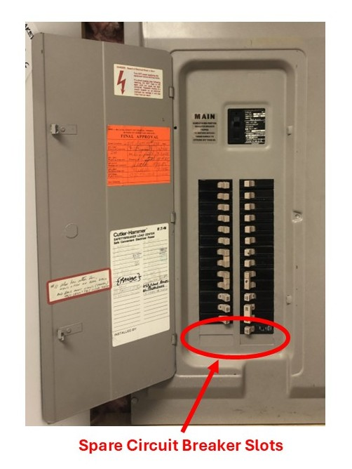
Figure 6: Spare slots for circuit breakers in a home power panel (Photo by Norbert Doerry)
  - Harmonic and common mode currents
If the load currents have significant non-fundamental frequency components or common mode components, then the size of the bus bars should be increased to prevent excessive heat generation. Specifications, datasheets and other information from the manufacturer should be consulted to estimate the impact of non-fundamental frequency current components and common mode current components.
  - Survivability
The rating of switchboards, load centers, and power panels should account for both normal operation and for cases where additional load is applied via bus transfers from other switchboards, load centers, or power panels. In this case, load shedding of lower priority loads may be required to supply all vital loads.
- References
IEEE Std 45.1, IEEE Recommended Practice for Electrical Installations on Shipboard—Design
MIL-DTL-23928, Panels, Electrical, Power Distribution and Manual Transfer, Circuit Breaker Type
DPC 310-1 Electric Power Load Analysis (EPLA) for Surface Ships
Doerry, Norbert, "Shipboard power system limiting load flow and load flow analysis", IEEE ESTS 2025, Alexandria VA, August 5-8, 2025.

